Schedule No. | SA - 000 [Revision #] | Document Type | Draft or Official | Date | April 25, 2017
Project | Project Name | Project No. | Project Number | YYC Contract # | Contract No.
YYC PM&Cell | Choose a manager. | Prepared by | Name / Cell Number | Contractor Job # | Company Job No.

INSTRUCTIONS
DRAFT Schedule Advisories cover the upcoming week from Monday to Sunday. They must be submitted to scheduleadvisory@yyc.com prior to 1200 on the Wednesday preceding the week of the scheduled work. Late submissions may not be reviewed, or approved.

OFFICIAL Schedule Advisories are issued after YYC reviews of all DRAFTS received. Any changes required for work to proceed will be communicated to the Project Manager and submitter of the Schedule Advisory, prior to scheduleadvisory@yyc.com distributing the OFFICIAL Thursday afternoon.
The Corps of Commissionaires will confirm security escort availability to scheduleadvisory@yyc.com and the Project Manager by Friday at 1200 via email.

REVISIONS are changes to the OFFICIAL Schedule Advisory after their distribution by scheduleadvisory@yyc.com. They must be sent in with all changes highlighted in yellow. Cancellation, or removals of information should be highlighted with a strikethrough. Changes submitted after 1600 may not be accommodated until the following work day.

Please note that all time are local times and work is dependent on suitable weather. Pullback distances are measured from taxiway centerline, and pullback time is the time required for a contractor to pullback after being notified. Cont. = Continuous Restriction.

Escort Types: D – Airfield Driver for taxiways and runways, D/A – Apron Driver, E – Echo Escort, on foot

OPERATIONAL IMPACTS

Taxiways
# | Restriction | Pull-Back | Time | Type | Start | Finish | Reoccurring Until
1 | Taxiway TWY / RWY - Type of Restriction  Between TWY / RWY and TWY / RWY | Y/N | 0000 – 0000 | Y/N | Monday, April 10, 2017 | Friday, April 14, 2017 | Click to enter date.
2 | Taxiway TWY / RWY - Type of Restriction  Between TWY / RWY and TWY / RWY | Y/N | 0000 – 0000 | Y/N | Monday, April 10, 2017 | Friday, April 14, 2017 | Click to enter date.

Runways
# | Restriction | Pull-Back | Time | Type | Start | Finish | Reoccurring Until
1 | Runway Name - CLOSED  Detail (Taxi availability, etc.) | Y/N  Time | 0000 – 0000 | Y/N | Monday, April 10, 2017 | Friday, April 14, 2017 | Click to enter date.
2 | Runway Name - Type of Restriction  Detail (Taxi availability, etc.) | Y/N  Time | 0000 – 0000 | Y/N | Monday, April 10, 2017 | Friday, April 14, 2017 | Click to enter date.

Other Areas (Apron, VSR, etc.)
# | Restriction | Time | Type | Start | Finish | Reoccurring Until
1 | Area - Impact  Detail | 0000 – 0000 | Y/N | Monday, April 10, 2017 | Friday, April 14, 2017 | Click to enter date.
2 | Area - Impact  Detail | 0000 – 0000 | Y/N | Monday, April 10, 2017 | Friday, April 14, 2017 | Click to enter date.

SCHEDULE DETAILS
Operational Impact # | Scope of Work, Location, and Equipment
Item # | (Describe work being done airside that does impact operations)
Item #
No Operational Impact Work | (Describe work being done airside that does not impact operations)

CRANES
Will Crane/Equipment causing obstructions be required? NO | If YES: Crane Application Number: YYC(T)###
Obstacle limitation forms can be found under Crane Approvals: http://www.yyc.com/en-us/businessatyyc/formsapplications.aspx
Crane Application Numbers can be received by submitting your permits to cranes@yyc.com

ESCORT REQUIREMENTS
Lead escorts and contractor(s) to meet on-site at least 30 minutes prior to scheduled restriction.
Date | Time | # of People On Site | Meeting Gate/Place | # and Type of Escorts Required
Monday, April 10, 2017 | 0000 – 0000 | Choose an item. | Meeting Place | Choose an item. Escort Type
Tuesday, April 11, 2017 | 0000 – 0000 | Choose an item. | Meeting Place | Choose an item. Escort Type
Wednesday, April 12, 2017 | 0000 – 0000 | Choose an item. | Meeting Place | Choose an item. Escort Type
Thursday, April 13, 2017 | 0000 – 0000 | Choose an item. | Meeting Place | Choose an item. Escort Type
Friday, April 14, 2017 | 0000 – 0000 | Choose an item. | Meeting Place | Choose an item. Escort Type
Saturday, April 15, 2017 | 0000 – 0000 | Choose an item. | Meeting Place | Choose an item. Escort Type
Sunday, April 16, 2017 | 0000 – 0000 | Choose an item. | Meeting Place | Choose an item. Escort Type
* In escorts required column indicates that work goes to next morning

Safety/Security – Persons/Equipment accessing airside areas must do so under the direction of a security escort. All persons require a security pass and must present valid Government Issued photo identification in order to receive the security pass. If work is being conducted on or adjacent to active runways, taxiways and aprons; care must be taken to maintain required clearance distances. Any deviation to the Schedule Advisory must be approved by the Airport Duty Manager (403)735-1300 at least 60 minutes prior to restriction expiry.

CONTACTS - CCoC
 | Name |  | Phone Number(s)
1 | CCoC Field Coordinator | Field.Coordinator@yyc.com | 403-333-2765
2 | CCoC Duty Supervisor |  | 403-735-7423

CONTACTS - PROJECT
 | Name | Company | Phone Number(s)
1
2
3
4
5
6

TERMINAL AREA & ESCORT LOCATION
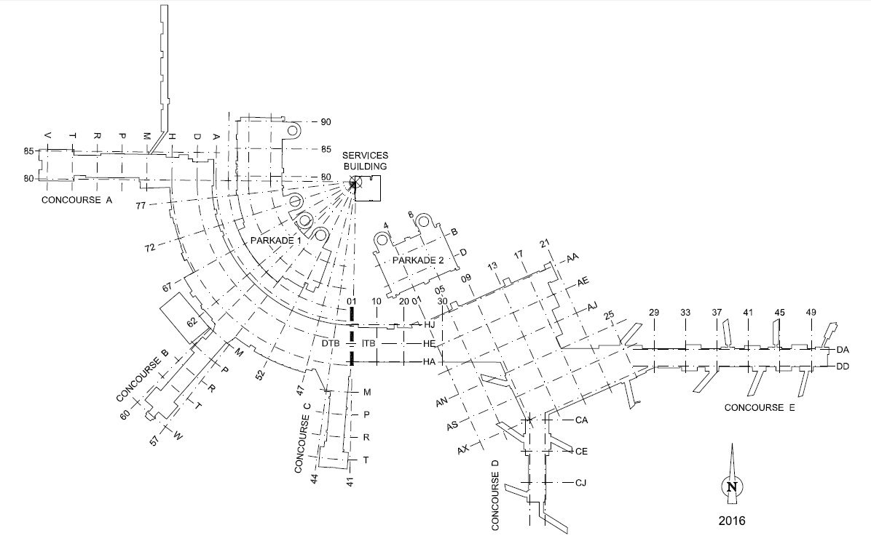
Work Area
Meeting Area

AIRFIELD AREA & ESCORT LOCATION (MAIN GATES AND LANDMARKS SHOWN)
LOC29
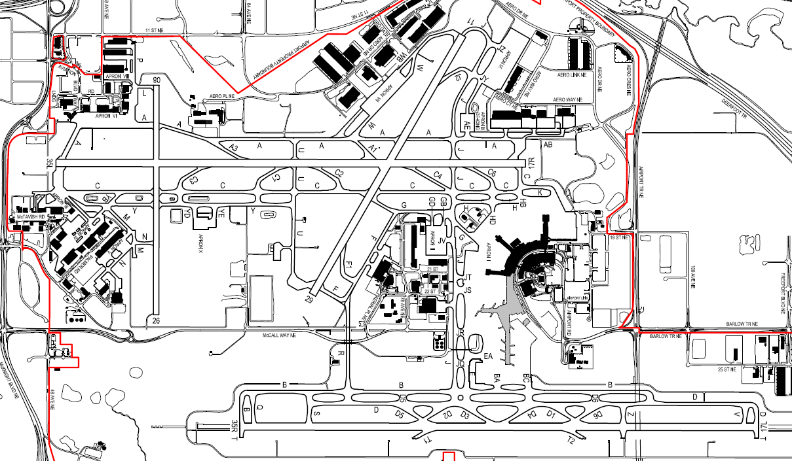
400
452
GP11

EMERGENCY RESPONSE GATE WEST
420
402
103C
401
GP35L
West FEC
LOC17R
LOC35L
GP17R

Highlight work area.
Circle Escort meeting place.

201
Transmitter Site
320
GP29
302

306A
235
LOC11

509
507
508
Receiver Site

East
FEC
505

504
LOC17L
LOC
35R
502
503
EMERGENCY RESPONSE GATE EAST
GP17L
GP35R

