Ground Transportation & Parking Form
Employee Parking Permit Application
Employee Parking Office
Monday – Friday 8:00 – 4:00
(Closed for lunch)

403-735-1444

Applicants must appear in person with this completed form to the Employee Parking Office located in the Main Terminal, Mezzanine Level.

Employee Name |  |  |  |  |  |  |  | DATE
Street Address
City |  |  | Province |  | Postal Code |  |  | Telephone
Company/Organization |  |  |  |  | Department
Email Address
LOT: | Green □ | Blue □ |  | North Red □ | Yellow □ | White □ |  |  | Orange □
Vehicle #1
Make |  |  | Model |  | License Plate |  | PROVINCE |  |  | Color
Vehicle #2
Make |  |  | Model |  | License Plate |  | PROVINCE |  |  | Color
I have read and understand the parking regulations. I agree it is solely my responsibility to abide by these regulations and understand that a violation of one or more of these regulations may result in ticketing, towing and/or loss of my parking privileges. For the purpose of this Parking application I consent to the collection and storage of the personal information and I understand that the information will be stored in the RAIC and Access Control computer systems of Calgary International Airport, and that I may obtain a copy of the stored information upon request.
Applicant Signature |  |  |  |  | Date
COMPANY AUTHORIZATION FOR NEW PERMIT Issuance of Employee Parking Permit to the above named Permit Holder is authorized by:

Name ________________________ Position_______________________ Company_______________________

Signature____________________________________________________ Date___________________________
- It is the responsibility of an invoiced company to ensure that their employee’s parking permit/ProxCard is returned to the Employee Parking Office upon their termination.
- Billing will continue until the permit and ProxCard have been returned or Lost/Stolen fees paid. The fee for a Lost/Stolen/Non-Returned parking Permit/Prox is $25.00 (+GST). The fee is refundable on return of Permit/ProxCard card within 30 days of deactivation and/or notice.
- Parking rates and/or associated fees are subject to change without notice.

Please complete this application and bring it with you to the Employee Parking Office.

OFFICE USE ONLY
PERMIT # _________ PROX # ___________ EXPIRATION: ___________ COPY PROVIDED TO CUSTOMER: Y / N

Ground Transportation & Parking Form
Employee Parking Map & Regulations
PARKING LOT ACCESS: Vehicle dash permits will be administered and RAIC will be programmed with access. Employees with temporary RAIC will be issued a temporary ProxCard (with 3 month expiration) until they have received permanent clearance.
Should any access problems or issues occur, there are intercoms at entrance/exit of the lot for 24 HR assistance.
Employees must notify Parking Office of all instances where a vehicle will be picked up or dropped off for them by a family member and/or friend.

VEHICLE STORAGE: As parking spaces are limited, the maximum length of stay, on a single entry, is 30 days and illegal parking (i.e. fire lanes, Handicap stalls, landscaped areas, etc) will be strictly prohibited. Violators may be ticketed and/or towed at owner’s expense and parking privileges will be revoked.

ACCOUNT INFORMATION CHANGE? Please notify the Parking office at 403-735-1444 of any changes to account information (For example. billing information, phone number, vehicle information, etc.)

FORGOTTEN/LOST/STOLEN HANG TAG/ACCESS? Hang tags MUST be displayed in vehicle at all times; if more than one vehicle is owned the hang tag must be moved back and forth.
A $25 (+gst) fee will be assessed for the replacement of a lost/stolen hang tag; if the permit is found within 30 days a refund will be administered.

PARKING PERMIT CANCELLATION/EMPLOYMENT TERMINATION: The vehicle hang tag MUST be returned to your employer or the Parking Office in order to cancel parking.
A $25 (+gst) fee will be assessed for any unreturned hang tag; if the permit is returned within 30 days of the cancellation/deactivation a refund will be administered.
Parking is leased on a month to month basis and may be terminated by the Airport Authority with 30 days notice.

ACCESSIBLE PARKING: Accessible parking is available, in all lots, for those employees holding a valid Government issued disability placard or for temporary disability/injury.
Accessible Parking requests must be obtained and submitted by your employer.
Length of stay in an accessible parking stall is limited to 24 hours; if a longer time period is required please contact the Parking Office for approval.

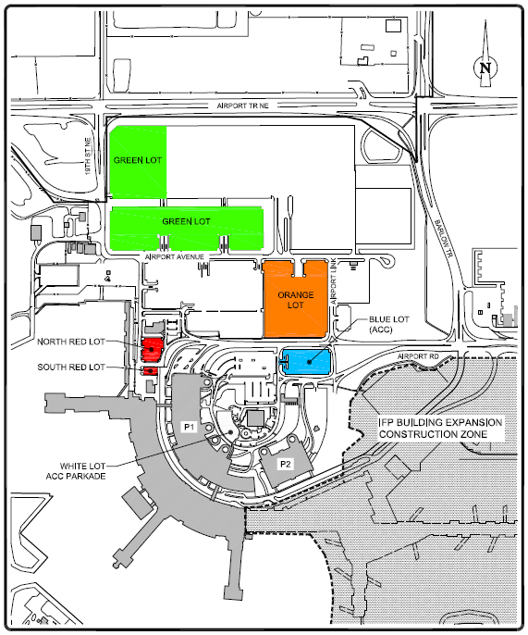

Should you have any further questions regarding the employee parking facilities or your employee parking hang tag, please contact the Airport Authority Parking Office at 403-735-1444 or parking@yyc.com
.

